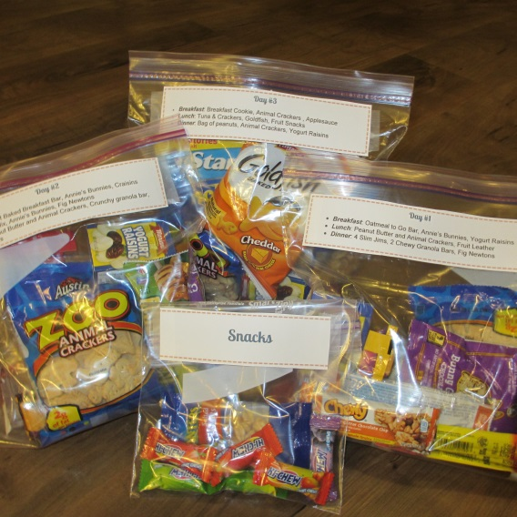

For More Info Visit: www.YourOwnHomeStore.com/72-hour-food-kit

The Menu:

**Day #1**

* ***Breakfast***: Oatmeal to Go Bar, Annie’s Bunnies, Yogurt Raisins
* ***Lunch***: Peanut Butter and Animal Crackers, Fruit Leather
* ***Dinner***: 4 Slim Jims, 2 Chewy Granola Bars, Fig Newtons

**Day #2**

* ***Breakfast***: Soft Baked Breakfast Bar, Annie’s Bunnies, Craisins
* ***Lunch***: Trail Mix, Annie’s Bunnies, Fig Newtons
* **Dinner**:  Peanut Butter and Animal Crackers, Crunchy granola bar, Yogurt Raisins

**Day #3**

* ***Breakfast***: Breakfast Cookie, Animal Crackers , Applesauce
* ***Lunch***: Tuna & Crackers, Goldfish, Fruit Snacks
* ***Dinner***: Bag of peanuts, Animal Crackers, Yogurt Raisins

#### Add-Ons:

**Additional bag of nuts per day:**

* Adds 170 calories per day

**3 Additional Slim Jims per day:**

* Adds 130 calories per day

**6 pieces chewy candy per day:**

* Adds 130 calories per day,

**Peach Drink:**

* Adds 275 - 306 calories per day, and LOTS of vitamins.  Enough for approximately 1 cup peach drink at each meal per person.

What Makes This Kit So Great?

**High in Calories:**

In many disaster situations, you actually would not need your kit b/c you’d be able to stay home.  In reality, the only time you’d actually *use* your kit is if you had to quickly evacuate ***and*** the evacuation radius was wide enough that you couldn’t quickly get to a family / friend’s home.  This means, you’d likely be expending a lot of energy and would need calories.  Many other 72 hour food kits you can find online only offer 600-1000 calories / day.  A large scale disaster is ***not*** the time to cut your calorie consumption by half or more. Hunger makes me AND my kids (and maybe you?) very grumpy. This kit offers *at least* 1500 calories per day.

**Nothing Needs to Be Cooked:**

Everything is lightweight and easy to carry. All meals are simple to prepare / eat which is ideal in a stressful emergency situation. Also, this means there is no need to carry or have the extra expense of a small stove / mess kits.

**Low Cost:**

The basic kit costs just under $12 for 9 meals! That is far less than $2 per meal. Even if you include all the add-ons, the cost is still under $16 for 9 meals: still under $2 per meal!

**Flexible**:   
If you want just the basic kit, you can do that for under $12 and still get over 1500 calories per day. But, if you’d like a few more calories, you can add nuts, slim jims and / or candy as snacks. In addition, you can add a vitamin fortified (with vitamins A, D, C, E B6, B12, Zinc, Niacin, Folate and Biotin) drink mix to add a nutrition ***and*** calorie boost.